KNF-700/KNF-700G underground multi-parameter gas detection terminal
-detection of methane, hydrogen sulfide, CO, oxygen, air pressure, temperature, liquid level, etc.

Main features:
1、3.6V large-capacity battery, which lasts for more than 2 years in factory mode;
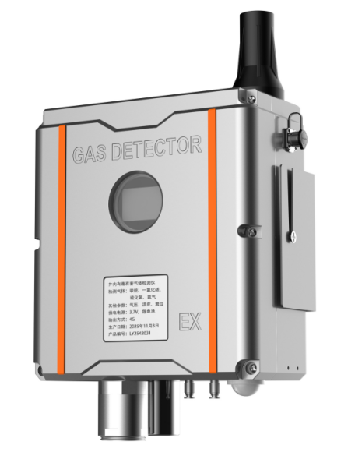
2、Tunable laser absorption spectrum analysis and detection of methane concentration has good selectivity;
3、Simultaneous detection of H2S, CO, O2, temperature and air pressure;
4、The function of detecting liquid level height can be selected, and the maximum error is less than 5 mm;
5、External expansion interface to realize other functions;
6、Suitable for the installation and use of inspection wells, not affected by humid air;
7、Air pump sampling, not afraid of soaking water,
8、4G transmission, strong adaptability;
9、GPS and Beidou positioning function (wireless version)
10、3 years of free traffic;
11、By default, it is detected once every 30 minutes, and the data is transmitted once every 24 hours. The number of annual events is 50, and there is no network failure. The data is successfully transmitted once.
12、Upload data immediately if the alarm threshold is exceeded (no more than 3 times a day)
13、Explosion-proof design, IP68 protection and corrosion resistance.
Electrical parameters of products:

product model | KNF-700(RS485 wired model) /KNF-700G(4G and battery model)
Measuring parameter | Methane, H2S, CO, O2 (other gases can be expanded); Pressure, temperature, liquid level, etc.
Working temperature | -20~50℃
Humidity of working environment | 10~99%RH
Sampling interval | 30~1440 minutes adjustable (default 30 minutes)
Data upload interval | Adjustable for 60~1440 minutes (data will be transmitted online immediately after the alarm threshold is exceeded).
Wired output | RS485
Wireless mode | 4G、433MHz
Positioning function | GPS and Beidou positioning
power supply mode | 3.6v lithium battery, 150Ah (optional)
endurance | More than 2 years (not less than 24-hour regular reporting interval is recommended)
Working temperature | -20℃~ +60℃
Working humidity | ≤98%RH
Appearance characteristics | Integrated
Installation mode | Installation of manhole side wall
Main body size | 370x220x116mm (excluding mounting bracket)
the protection grades | IP68
explosive-proof grade | EX d IIC T6 Gb

Detection parameters:
Detection object | Main parameter
methane  (laser TDLAS) | measuring range | 0~20%VOL
methane  (laser TDLAS) | precision | 0 ~ 1% vol: 0.1% (absolute error); 1 ~ 20% vol: 10% (relative error)
methane  (laser TDLAS) | resolution ratio | 0.01%
methane  (laser TDLAS) | life | More than 3 years
H2S  (hydrogen sulfide) | measuring range | 0 ~ 100 ppm, other ranges are optional.
H2S  (hydrogen sulfide) | precision | ≤±5%FS
H2S  (hydrogen sulfide) | resolution ratio | 1ppm
H2S  (hydrogen sulfide) | Service life | More than 2 years
CO  (carbon monoxide) | measuring range | 0～1000ppm
CO  (carbon monoxide) | precision | ≤±5%FS
CO  (carbon monoxide) | resolution ratio | 1ppm
CO  (carbon monoxide) | life | More than 2 years
O2  (oxygen) | measuring range | 0～25% vol
O2  (oxygen) | precision | ≤±2% FS
O2  (oxygen) | resolution ratio | 0.1%
O2  (oxygen) | life | More than 2 years
atmospheric pressure | measuring range | 300～ 1100hPa
atmospheric pressure | precision | ±4hPa
atmospheric pressure | resolution ratio | 1hPa
atmospheric pressure | life | More than 3 years
temperature | measuring range | -40~80℃;
temperature | precision | ±1℃
temperature | resolution ratio | 0.1℃

Installation dimension (unit: mm)
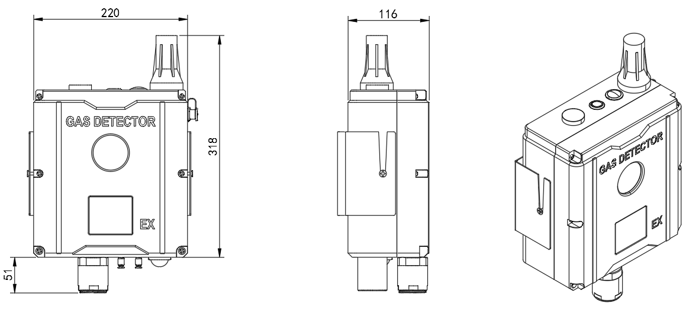

Installation location:
The equipment shall be installed at a distance of 15 ~ 20cm below the ground, and the mounting frame shall be fixed on the shaft wall with expansion screws or cement nails, and the terminal shall be placed on the mounting frame.
In the place with good signal quality, the antenna can be installed at the exit 15~20cm away from the surface in the well. If the signal quality in the field is not good, it is necessary to configure a split antenna and install the equipment antenna on the ground. The specific method is to cut an installation slot in the road near the wellhead, with a length of 18cm, a width of 7cm and a depth of 3cm. Put the equipment antenna in and cover it with cement/asphalt to restore the road surface.
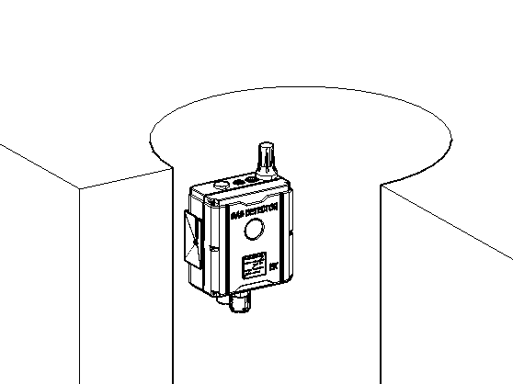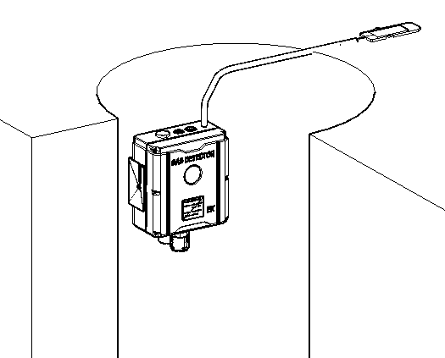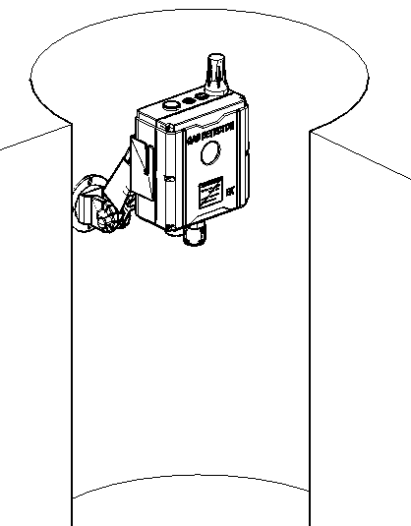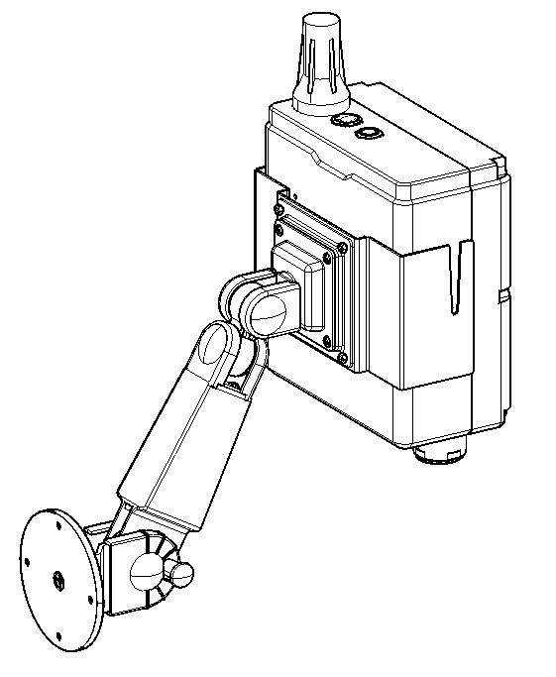
Mode 3: The radar liquid level measurement is blocked, and the equipment needs to be extended through the rotating arm.

Mode 2: The underground signal is weak, and the antenna is buried in the shallow ground.

Mode 1: Integrated installation
.

Quality assurance:
The warranty period of this product is within one year from the date of delivery. Any product repaired or replaced during the warranty period is only the unexpired time remaining in the original warranty period.
The warranty scope does not include the normal wear and tear of the product, nor does it include the defects caused by abuse, accident, misuse, modification or modification, and it is not responsible for the defects caused by the failure to install, maintain or use the product according to the instructions in this manual.

